**Probability and Statistics**

**Lab Sheet 03**

Exercise:

1.

2.

**Branch**: numeric/integer (ID) → **Nominal**

**Sales_X1**: numeric (continuous) → **Ratio**

**Advertising_X2**: numeric (continuous) → **Ratio**

**Years_X3**: numeric/integer (discrete) → **Ratio**

3.

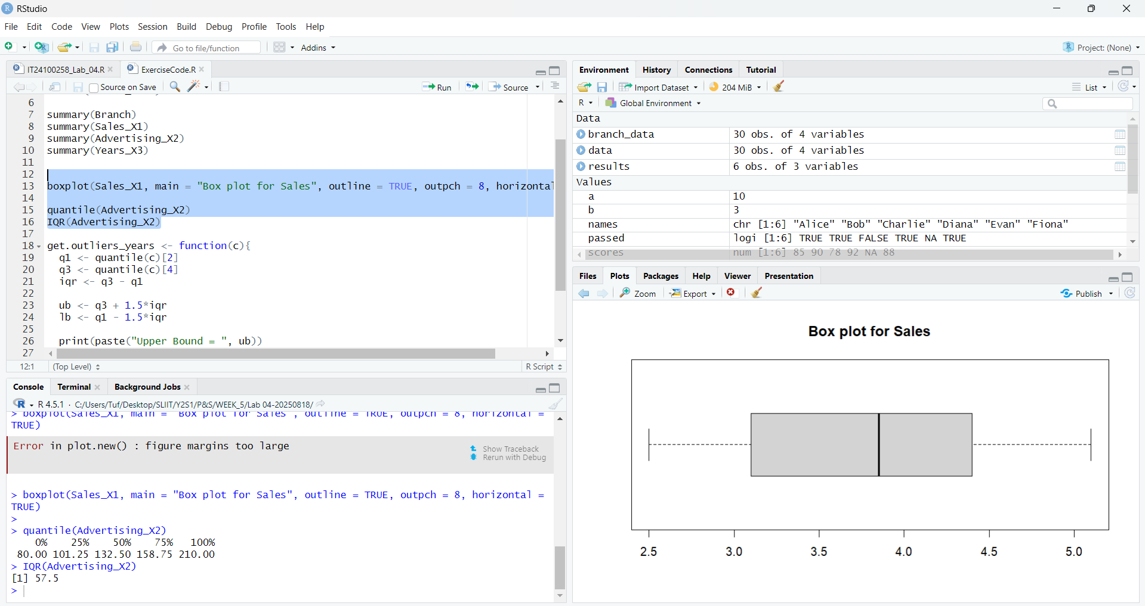

4.

5.

